**Assignment 2.6**

Dataset: <https://drive.google.com/open?id=0ByJLBTmJojjzZTJQM2UzN2J6aUU>

Load Data:

Load_Data = LOAD '/home/acadgild/Pokemon.csv' USING PigStorage(',') AS(Sno:int,Name:chararray,Type1:chararray,Type2:chararray,Total:int,HP:int,Attack:int,Defense:int,SpAtk:int,SpDef:int,Speed:int);

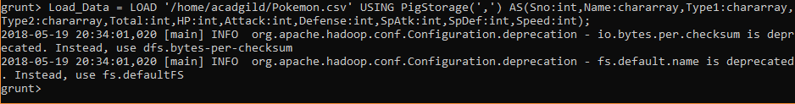

1. **Find the list of players that have been selected in the qualifying round (DEFENCE>55).**

selected_list = FILTER Load_Data BY Defense>55;

dump selected_list;



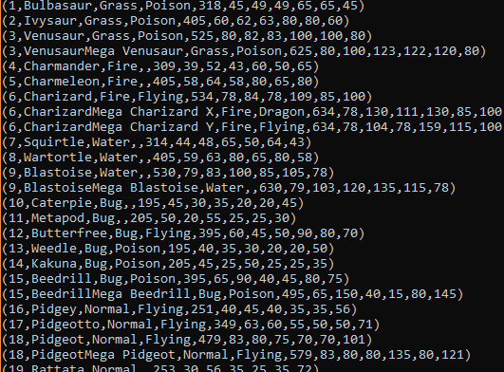

1. **State the number of players taking part in the competition after getting selected in the qualifying round.**

group_selected_list = Group selected_list All;

count_selected_list = foreach group_selected_list GENERATE COUNT(selected_list);

dump count_selected_list;





1. **Using random() generate random numbers for each Pokémon on the selected list.**

random_include1 = foreach selected_list GENERATE RANDOM(),Name,Type1,Type2,Total,HP,Attack,Defense,SpAtk,SpDef,Speed;

dump random_include1;



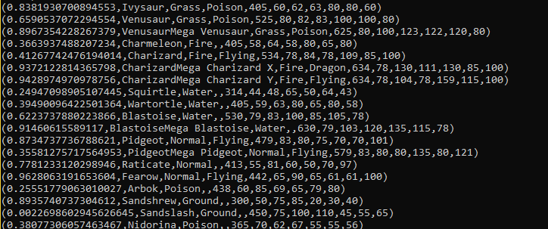

1. **Arrange the new list in a descending order according to a column randomly.**

random1_desending = ORDER random_include1 BY $0 DESC;

dump random1_desending;



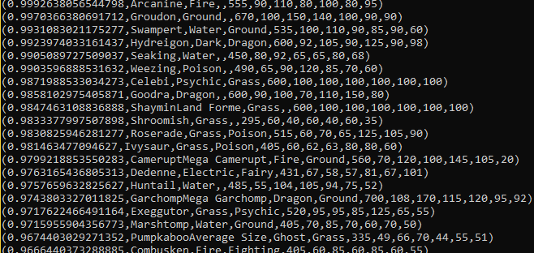

1. **Now on a new relation again associate random numbers for each Pokémon and arrange in descending order according to column random.**

random_include2 = foreach selected_list GENERATE RANDOM(),Name,Type1,Type2,Total,HP,Attack,Defense,SpAtk,SpDef,Speed;

random2_desending = ORDER random_include2 BY $0 DESC;



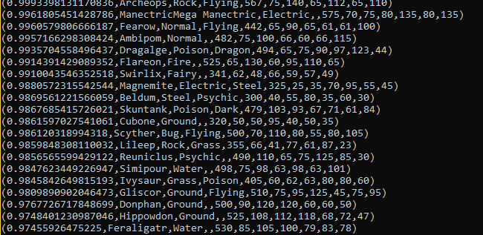

1. **From the two different descending lists of random Pokémons, select the top 5 Pokémons for 2 different players.**

limit_data_random1_desending = LIMIT random1_desending 5 ;

dump limit_data_random1_desending;



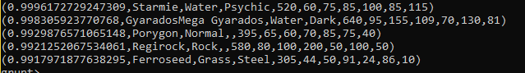

limit_data_random2_desending = LIMIT random2_desending 5 ;

dump limit_data_random2_desending;



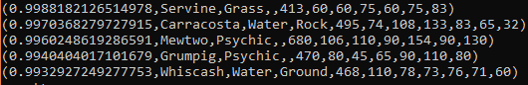

1. Store the data on a local drive to announce for the final match. By the name player1 and player2 (only show the NAME and HP).

filter_only_name1 = foreach limit_data_random1_desending Generate ($1,HP);

dump;



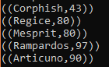

filter_only_name2 = foreach limit_data_random2_desending Generate ($1,HP);

dump;



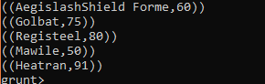

STORE limit_data_random1_desending INTO ‘/home/acadgild/player1.txt’;

STORE limit_data_random2_desending INTO ‘/home/acadgild/player2.txt’;



